Determining lesion size for MBS item selection
Last updated: 04 May 2023
The necessary excision diameter (or defect size) refers to the lesion size plus a clinically appropriate margin of healthy tissue required with the intent of complete surgical excision. Measurements should be taken prior to excision. Margin size should be determined in line with current NHMRC guidelines. Currently these are the:
- Clinical practice guidelines for keratinocyte cancer: basal cell carcinoma, squamous cell carcinoma and related lesions November 2019. Cancer Council Australia; and the
- Clinical practice guidelines for the diagnosis and management of melanoma (2019).
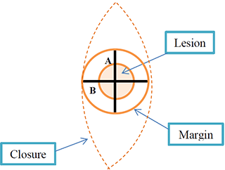
For the purpose of items 31356 to 31388 the defect size is calculated by the average of the width and the length of the skin lesion and an appropriate margin. Therefore, the necessary excision diameter is calculated as follows:
An incomplete surgical excision of a malignant skin lesion made with curative intent should be billed as a malignant skin lesion excision item even when further surgery is needed.
Practitioners must retain copies of histological reports and any other supporting evidence (patient notes, photographs etc). Photographs should include scale.
An episode of care includes both the excision and closure for the same defect, even when excision and closure occur at separate attendances.

Where can I find more information?
The full item descriptor(s) and information on other changes to the MBS can be found on the MBS Online website at www.mbsonline.gov.au. You can also subscribe to future MBS updates by visiting MBS Online and clicking ‘Subscribe’.
The Department of Health and Aged Care provides an email advice service for providers seeking advice on interpretation of the MBS items and rules and the Health Insurance Act 1973 and associated regulations. If you have a query relating exclusively to interpretation of the Schedule, you should email askMBS@health.gov.au.
Subscribe to ‘News for Health Professionals’ on the Services Australia website and you will receive regular news highlights.
If you are seeking advice in relation to Medicare billing, claiming, payments, or obtaining a provider number, please go to the Health Professionals page on the Services Australia website or contact the Services Australia on the Provider Enquiry Line – 13 21 50.
The data file for software vendors when available can be accessed via the Downloads page.
Please note that the information provided is a general guide only. It is ultimately the responsibility of treating practitioners to use their professional judgment to determine the most clinically appropriate services to provide, and then to ensure that any services billed to Medicare fully meet the eligibility requirements outlined in the legislation.
This sheet is current as of the Last updated date shown above and does not account for MBS changes since that date.

